QUIZ 3

21L-7512

ABDULLAH DAR

BSCS 3 G

CODE

[org 0x0100]

jmp start

text1: db 'Hi, you pressed a ', 17

text2: db 'Hi, you pressed b ', 17

text3: db 'Wrong Credentials ', 18

counter: dw 0

clrscr:

push es

push ax

push cx

push di

mov ax, 0xb800

mov es, ax

xor di, di

mov ax, 0x0720

mov cx, 2000

cld

rep stosw

pop di

pop cx

pop ax

pop es

ret

printstr:

push bp

mov bp, sp

pusha

mov ax,18

cmp ax, 0

jz exitt

mov cx, ax

mov ax, 0xb800

mov es, ax

mov al, 80

mul byte [bp+8]

add ax, [bp+10]

shl ax, 1

mov di,ax

mov si, [bp+4]

mov ah, [bp+6]

cld

nextchar: lodsb

stosw

loop nextchar

exitt:

popa

pop bp

ret 8

pressa:

mov ax, 0

push ax

mov ax,2 ; x

push ax

mov ax, 0x71 ; y

push ax

mov ax, text1

push ax

call printstr

jmp return1

pressb:

mov ax, 0

push ax

mov ax, 4 ; x

push ax

mov ax, 0x71 ; y

push ax

mov ax, text2

push ax

call printstr

jmp return1

else:

mov ax, 0

push ax

mov ax, 6 ; x

push ax

mov ax, 0x71 ; y

push ax

mov ax, text3

push ax

call printstr

jmp return1

start:

mov ah,0

int 0x16

call clrscr

mov cx,4

loop1:

mov ah,0

int 0x16

cmp al,0x61

je pressa

cmp al,0x62

je pressb

jne else

return1:

loop loop1

mov ax,0x4c00

int 0x21

OUTPUT

BEFORE

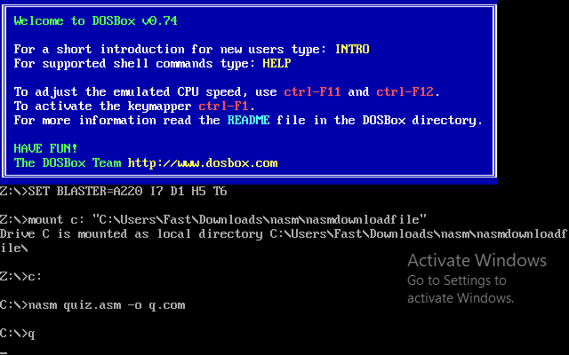

AFTER

